**IOT based gas leak detection and removal system.**

**Abstract:**

LPG Gas is one of the most common household thing in our daily life. The best part of LPG gas is It is clean as compared to charcoal and hearth. LPG Gas is mostly used in urban area.

Gas leakage is a major problem in the residential area, industrial sector etc. LPG Gas is highly flammable. nowadays, there has been an increase number of Gas leakage incidents. These leakage accidents can cause huge fire and explosion. The purpose of these project is to detect the gas leakage and switch off home appliances till gas leak persists.

**Keywords:**

MQ-2 Gas Sensor, Esp32 development board, 4 channel Relay, Buzzer, Home appliances (Light, Fan, Exhaust fan), IOT,

**2 Introduction:**

Now a days the home safety detection system plays the important role for the security of people. Since, everyone goes out of their homes for work on daily bases, it makes impossible to check on the home appliances specially LPG gas cylinder and wired circuits, Etc.

This design is about prototyping a simple device to monitor gas leakage anywhere and anytime to protect human life. The system has a gas sensor, connected to a ESP32 development board and it monitor fumes level in the environment, after a certain level, Alarm will activated. Home appliances such as light, fan will be switched off and the Exhaust fan will turn on automatically. The Leaked gas will be extracted using Exhaust fan from the place of incident.

**2.1 Problem Statement:**

Now a days Liquified Petroleum Gas (LPG) is generally used in households, industries and other places as it is very convenient, affordable and less dangerous than its other alternatives.

Hence, it can leak both as a liquid or as a gas if it is not handled cautiously. Accidents and disasters related to LPG gas leakage are not unheard of. These leakage accidents can cause huge fire and explosion.

These accidents are caused usually caused due to negligence and careless handling of the gas. If the gas leakage is not detected in the early stages, then it can lead to a very big disaster, as nowadays we can find the supply of LPG gas in almost every household. So, a lot of people have to face danger in case of such apocalypse.

**2.2 Literature Review/Description of Present System**

**2.3 Background /Limitations**

* The range of gas leak detection sensors can be limited, which means that multiple sensors may be required to cover large areas. This can increase the cost of the system.
* The systems can be expensive, particularly when multiple sensors are required to cover large areas.
* Gas leak detection and removal systems must be compatible with the gas being detected and removed. Different gases require different sensors and removal methods, which can limit the system's versatility.

**2.4 Aim & Objectives:**

The aim of these project is To detect gas leaks timely manner for remove gas from the affected area and prevent potential hazards, and also prevent damage of equipment as well as property.

Develop a reliable gas detection sensor or system that can detect gas leaks in real-time manner and Integrate the gas detection system with a removal mechanism such as an exhaust or ventilation system to remove the gas from the affected area.

**2.5 Project Motivation**

Internet of Things (IoT) is the networking of ‘things’ by which physical things can communicate with the help of sensors, electronics, software, and connectivity. These systems do not require any human interaction and the same is the case with iot based gas detection system. It does not require human attention.

**3 Description of Proposed Work**

**3.1 Number of modules**

**Loop():**

Loops are used to control the flow of a program. In a loop, a block of code is  
executed over and over again. Each cycle of the loop is called an iteration of the loop.  
Depending on certain conditions that you can define in the code, you can control whether the program enters the loop or not.

**Setup():**

The setup() function is called when a sketch starts. It is used to initialize  
variables, pin modes, start using libraries, etc. The setup() function will only run once,  
after each powerup or reset of the Arduino board.

**3.2 Algorithm(threshold-value algorithm)**

**CODE:**

# Set up the sensor and threshold value

sensor_reading = get_sensor_reading()

threshold = 50

# Compare the sensor reading to the threshold value

if sensor_reading > threshold:

# Activate an alarm or trigger a response

activate_alarm()

else:

# Do nothing or continue monitoring

Pass

**Description for the code:**

1. Read the sensor data
2. Set a threshold value
3. Compare the sensor reading to the threshold value
4. If the sensor reading is above the threshold value, activate an alarm or trigger a response
5. If the sensor reading is below the threshold value, do nothing or return to step 1 to continue monitoring.

**3.3 Working:**

This code is an Arduino sketch that reads analog data from a gas sensor connected to pin 4 of the Arduino board and controls an LED and two relays based on the gas concentration level.

In the setup() function, the code initializes the serial communication with a baud rate of 115200, sets the LED and two relays pins as outputs.

In the loop() function, the code reads the analog data from the gas sensor using the analogRead() function and stores the result in the sensor_Aout variable. It then prints the gas sensor value to the serial monitor.

Next, the code checks if the gas concentration level exceeds a threshold value of 450. If the gas concentration level is above the threshold, the code turns on the LED and turns off the relays to activate a gas removal system. If the gas concentration level is below the threshold, the code turns off the LED and turns on the relays to deactivate the gas removal system.

Finally, the code adds a delay of 1 second using the delay() function before the loop repeats.

Overall, this code demonstrates a basic gas leak detection and removal system using an Arduino board, a gas sensor, an LED, and two relays. When the gas concentration level exceeds a threshold, the system activates the gas removal system to reduce the risk of a gas leak.

**3.4**

**3.5 Plagiarism report**

**3.6 Code**

int LED = LED_BUILTIN;

int realay1 = 23;

int realay2 = 22;

int Sensor_input = 4;

void setup() {

  Serial.begin(115200);

  pinMode(LED, OUTPUT);

  pinMode(realay1, OUTPUT);

  pinMode(realay2, OUTPUT);

}

void loop() {

  int sensor_Aout = analogRead(Sensor_input);

  Serial.print("Gas Sensor: ");

  Serial.print(sensor_Aout);

  Serial.print("\t");

  Serial.print("\t");

  if (sensor_Aout > 450) {

    Serial.println("Gas");

    digitalWrite (LED, HIGH) ;

    digitalWrite (realay1, LOW) ;

    digitalWrite (realay2, LOW) ;

  }

  else {

    Serial.println("No Gas");

    digitalWrite (LED, LOW) ;

    digitalWrite (realay1, HIGH) ;

    digitalWrite (realay2, HIGH) ;

  }

  delay(1000);

}

**4 Technology/Language/Development Tools/Hardware**

**Software Used  
 Arduino**  
• The Arduino Integrated Development Environment - or Arduino Software (IDE)- contains a text editor for writing code, a message area, a text console, a toolbar with buttons for common functions and a series of menus. It connects to the Arduino hardware to upload programs and communicate with them.

• Arduino is an open-source electronics platform based on easy to use hardware and software. Arduino boards are able to read inputs light on sensors, a finger on button, or a Twitter message - and turn it into an output activating a motor, turning  
on an LED, publishing something online. The user can tell the board what to do by sending a set of instructions to the Arduino/ESP32 microcontroller on the board.

• Arduino was born at the lvrea Integration Design Institute as on easy tool for fast prototyping, aimed at students without a background in electronics and programming

Hardware:

1. ESP32 Devlopment board
2. LED bulb
3. MQ3 Gas sensor
4. Brushless fan
5. 4-channel Relay
6. Buzzer
7. breadboard
8. Jumper wires
9. Battery
10. Gas Lighter
11. DC motor.

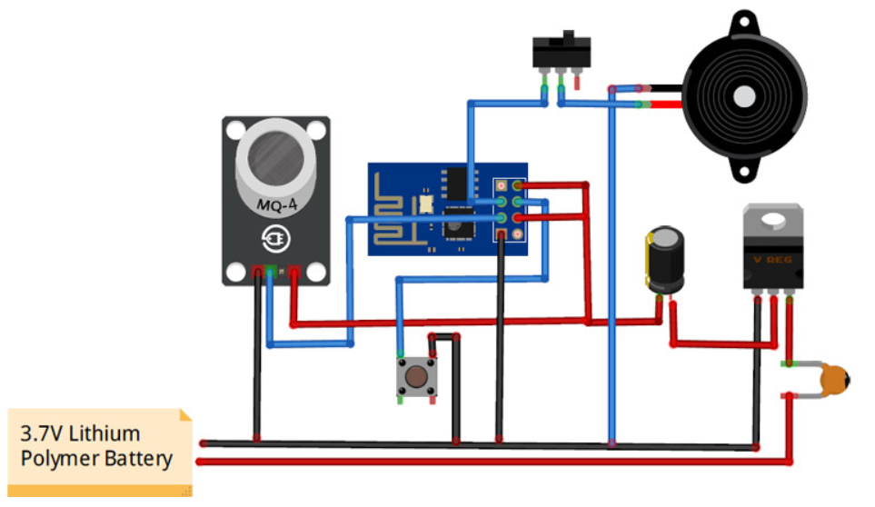

**5 Conclusion & Future Scope**

Thus, we would like to conclude that our system mainly focuses on home and industrial safety. By this, provides us with significance in the health department. Also, it leads to raise our economy, because when gas leaks it not only contaminates the atmosphere, but also wastage of gases will hurt our economy. Moreover, when the workers get affected, the job in the industry or factory cannot be continued, hence, affecting the economy.

Over the years, we have been marching towards various developments and advancements. This includes smart houses artificial intelligence etc. Smart houses can make our in-room living simple as much as it can. The control of fans and lights is now within our hands. Wi-Fi and software programming has put forth the initial steps towards the future to make control over the safety and other applications in the house. Another innovation that could push it a little further would be this gas detection sensor. As it ensures safety in our house from the gaseous hazards. Also, in industries and factories, we can avoid the disaster and ensure the safety of the workers.